

Release Notes

WBFWebParts.v0.9.5i.wsp
Installed onto live environment on 11/03/2014

Release Version v0.9.5i
11/03/2014



Table Of Contents

1. Version Summary 3
1.1 Source Code: 3
2. Installation Procedure 3
2.1 Remove and replace existing solution 3
3. New Features 4
3.1 Building a reporting facility to find where records are being used (Issue #61) 4
4. Updated Features 9

Copyright Notification
Copyright © London Borough of Islington 2014
This document is distributed under the Creative Commons Attribution 2.5 license. This means you are free to copy, use and modify all or part of its contents for any purpose as long as you give clear credit for the original creators of the content so used. For more information please see: http://creativecommons.org/licenses/by/2.5/

Version Summary
This version of the news rotator solution has the following changes:
From the list of issues in ‘Web Legacy Issues’ work package:
- Building a reporting facility to find where records are being used (Issue #61)

Source Code:
The source code for this release is being managed on the Team Foundation Server (TFS) here:
TFS Location | http://wbf.codeplex.com
Team Project | wbf
Solution Name | WBFWebParts
Release version | v0.9.5i
Release folder on TFS | WorkBoxFramework/WBFWebParts/Releases/v0.9.5i-final-2014.03.11/
WSP Filenames  (and download locations) | WBFWebParts v0.9.5i.wsp  WBFWebParts v0.9.5i - Public.wsp (version deployed in DMZ)
Changeset | 34878

Installation Procedure

Remove and replace existing solution
The new solution was installed on the public and protected SharePoint farms by first retracting and removing the existing version of the solution via Central Administration and the re-adding the solution using PowerShell. Notice that there is a slightly different version of the solution that is installed in the DMZ ‘public’ farm compared to the internal ‘protected’ farm.

Public farm version of WBFWebParts solution
The main change to the 'Public' version of this WSP is the inclusion of the WorkBoxFramework.dll as part of the solution as the main WorkBoxFramework.wsp solution is not installed in LBI DMZ.
The solution also has the InDMZ funtion set to return 'true' and the constant for the managed metadata service (in the WBF dll itself) is changed to use the connection to the internal MMS as appropriate for the DMZ. Both of these last two changes are not at all an ideal approach, but currently are necessary.
Once the existing WSP had been fully removed, then the new release was installed using:
PS> add-spsolution 'D:\<path_on_server>\WBFWebParts v0.9.5i - Public.wsp'
And then this solution was deployed onto the following web applications:
- http://liveextranets/
- http://liveevidencehub/
- http://nrpf.liveweb/
- http://liveweb/

Protected farm version of WBFWebParts solution
The protected, internal farm version of WBFWebParts solution does not have the WorkBoxFramework.dll included (as the main WBF solution is installed internally anyway, making the dll available to other solutions) and has the InDMZ function set to return false. The MMS service constant value is derived from the main WBF solution installed as the local MMS service.
Once the existing WSP had been fully removed, then the new release was installed using:
PS> add-spsolution 'D:\<path_on_server>\WBFWebParts v0.9.5i.wsp'

Then the solution was deployed onto the following web applications:
- http://sp.izzi/ (same web application as http://izzi/ )
- http://stagingweb/
- http://teststagingweb/
- http://nrpf.stagingweb/
- http://hass.izzi/
- http://collection.izzi/
- http://evidencehub.stagingweb/

New Features
The following are the new features in this release. (NB the word ‘feature’ is being used here in the general sense, not in the specific sense of a SharePoint solution feature).

Building a reporting facility to find where records are being used (Issue #61)
The Related Document web part and the Document Group web part being used by Islington are built on top of the WBF records management approach rather than using direct out-of-the-box SharePoint document management features. As a result it is not possible to which documents are being used where from within the ‘Content and Structure’ standard admin UI for a publishing site.
To address this issue the following functionality has been developed that allows the web team to search for where a given WBF public record is being used on the public website.

Post Installation Configuration
The feature is activated at the site level and attaches a new contextual menu option for all document libraries in that site. The name of the site level feature is:
- WBF Web Parts - Find Where Record Is Used Menu Item
So this feature was activated on the site:
http://stagingweb/publicrecords

How the updated feature was tested on UAT:
Browse to any page on http://uatstagingweb that has related documents. For the purposes here we will go to the page:
http://uatstagingweb/involved/consultation-engagement/Pages/consult_citizen.aspx
This page has a number of related documents, including the one highlighted in the screenshot below called: ‘Primary School Admissions Brochure’
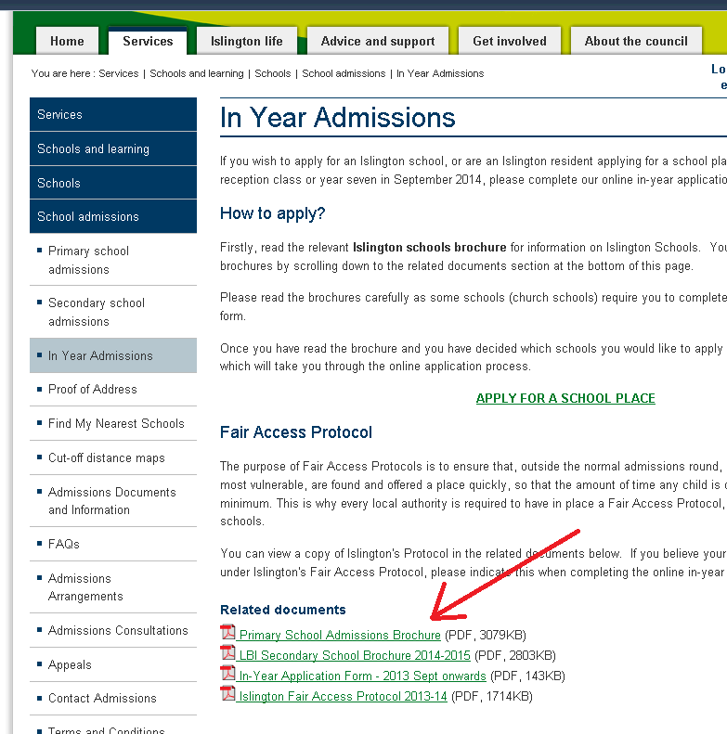

To find such a record in the public records library (we’ll be looking at the copy of this library that is on http://uatstagingweb/ ) You need to right click on the link highlighted above and copy the URL. If you then paste the URL into the browser as below:

And then remove the file name at the end of the URL as below:
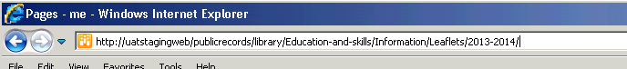

You will then have the URL for the folder in the public records library that holds this record, namely: http://uatstagingweb/publicrecords/library/Education-and-skills/Information/Leaflets/2013-2014/
Go to that folder and you should see something like the screenshot below and you should be able to find the record that you were looking at. Be careful to visually match both the title and filename of the record:
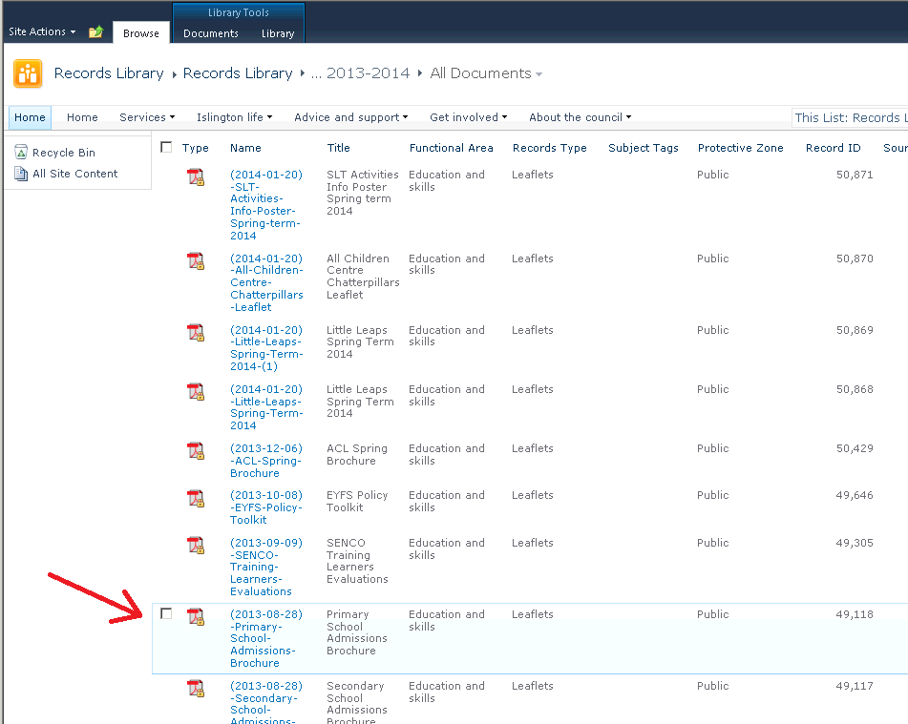
Then, to access the new feature you need to hover the mouse over the link for the record so that the context sensitive menu drop down appears and then select the new ‘Where is this record being used?’ option:
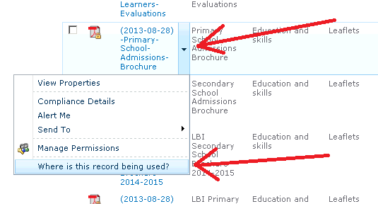

Then you should see the following dynamically updating report page:
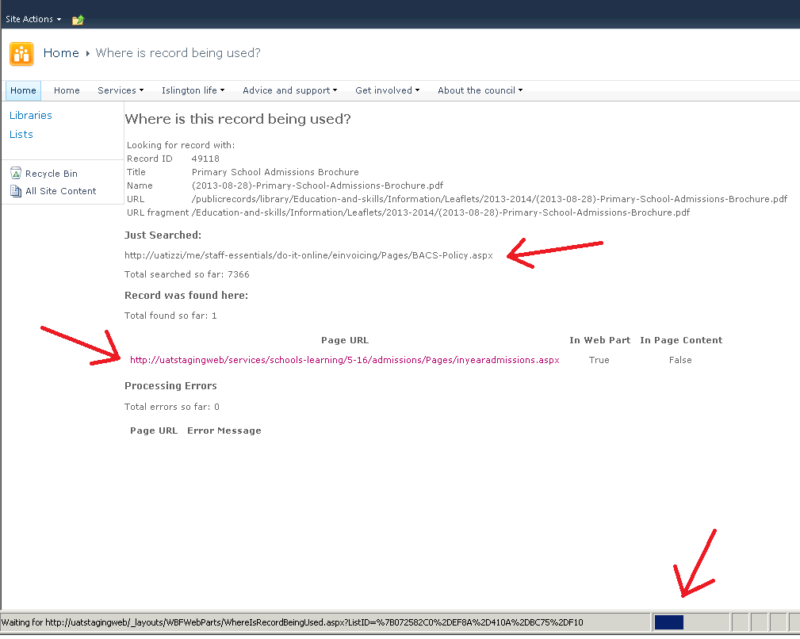

There are few important things to note about this report page:
- The search process can take a while (20 minutes or so) as the process looks at the page content and web parts of every page on each of the different sites being examined.
- The ‘Just Searched’ section of the page continues to update with the URL of the latest page examined while the search is going on.
- Any pages found to reference the record are dynamically output as they are found.
- Any errors are also displayed, partly for diagnostic reasons, but partly so that the user can manually check pages that the process, for whatever reason, was not able to successfully examine.
- The URLs for any pages found (or with errors) are listed as links so that you can easily go to the page in question and look at the usage of the record in context.
- The search looks across multiple sites that use the records being managed by WBF.

Once the search is complete, then the ‘Just Searched’ heading changes to read ‘Search Complete’ as seen in the screenshot below.
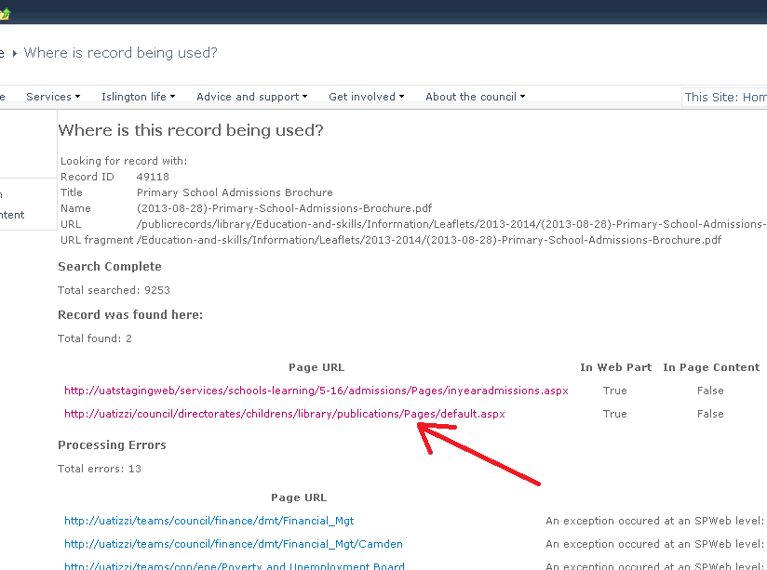

Notice that there were two pages found by this search to be using the record we’ve been looking at. The first page being the original page we started with above and the second being a page on the izzi intranet (see below).
The page on izzi found to be holding the same document:
http://uatizzi/council/directorates/childrens/library/publications/Pages/default.aspx
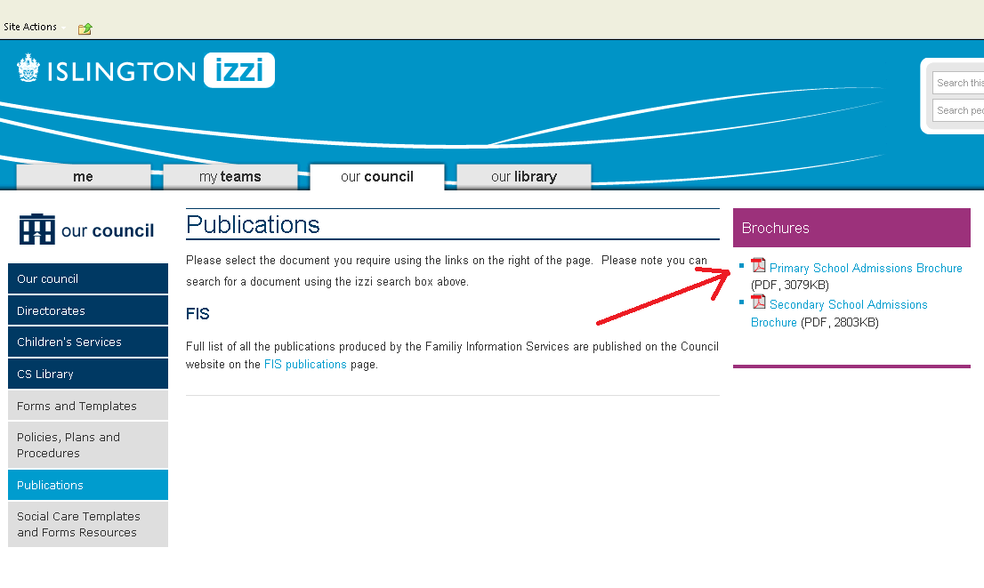

Known Issues
The following are the known issues:
- The search takes a long time to complete
- The search does not currently look at the content of Content Editor type web parts
- The set of web sites to search across is currently hardcoded and ought to be more easily configurable.
- The list of websites being searched ought to be displayed on the results page for reference.
Until further feedback on this feature has been received it does not make sense to attempt to address these known issues until there has been confirmation that the approach is the correct one.

Potential Future Improvements
Try to address the known issues.

Updated Features
There are no updated features in this release

